**Decision making and description (Sinh(x))**

**Decision making**

There are possible ways for implementing the HyperbolicSine class. During the possible ways, I choosed to implement it step by step as different functions.

So the formula for the Sinh(x) is $\frac{ⅇ^{x}-ⅇ^{-x}}{2}$. For the implementation faze, as the first function, $ⅇ^{x}$ is calculated. Then as the second function, $ⅇ^{x}-ⅇ^{-x}$ is implemented and in the final function, the total answer is calculated. This ways is chosen because it is easier to be followed by a reader. Then setter and getter for the class attributes are implemented.

**Pseudocode**

The pseudocode for the implementation is as follows:

Input: e as Euler number and a real or complex number as x

Output: the result of Sinh(x)

expPositive = e ** x

expNegative = e ** -x

numerator = expPositive – expNegative

return (numerator/2)

The time and space complexity of the algorithm O(1).

**Test**

As it can be seen in the following photo, the test has been done on two variable x. The first one is a real variable and the second one is the complex variable.

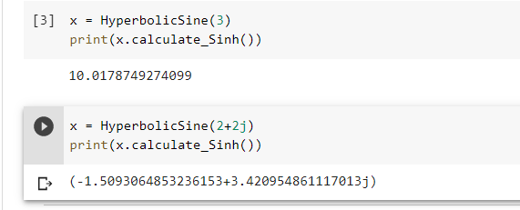

**Task**

Compute the multiplication of Sinh(2.5) with Sinh(3), and add the result to Sinh(2+2j) using the Sinh(x) Function((Sinh(2.5)*Sinh(3)) + Sinh(2+2j)).